Summary

2 Use-Cases 2

2.1. Actors 2

2.2. Use-Case Diagram 3

2.3. Use-Cases 4

Log-in (1) 4

Change password (2) 4

Log-out (3) 5

Delete account (4) 5

View player profile (5) 5

Set up game options (6) 5

Start game (7) 6

Confirm participation (8) 6

Throw TimeFlip die (9) 6

Stop TimeFlip die (10) 7

Confirm answer (11) 7

End game (12) 8

View statistics (13) 8

Create new subject (14) 8

Create new terms (15) 9

View open virtual game rooms (16) 9

Manage games (17) 9

Manage players (18) 10

Send notifications (19) 10

Set up game (20) 11

Start timer (21) 11

Select next player/term (22) 11

Stop timer (23) 12

Update score (24) 12

End game (25) 12

Move players (26) 13

# 2 Use-Cases

## 2.1. Actors

**User**

The use has an account to use the web application. Users can do actions such as login, logout, change the password and delete their account. Player, game manager and administrator are all users with different roles.

**Player**

The player is a user that apart from the basic actions of a user, he has many usage options regarding the TimeGuess game, in order to be able to play the game.

**Game Manager**

In addition to the options of a regular user, the game manager has more rights, like viewing all the open rooms, and the ability to improve the TimeGuess game by adding new terms.

**Administrator**

In addition to the options of a regular user, the administrator is responsible for the administration and management of the game and players. The admin can give rights to the players.

**Web Application System**

The system of the web application is responsible to randomly choose the next players and terms in the game and other tasks such as starting/ending the timer.

## 2.2. Use-Case Diagram

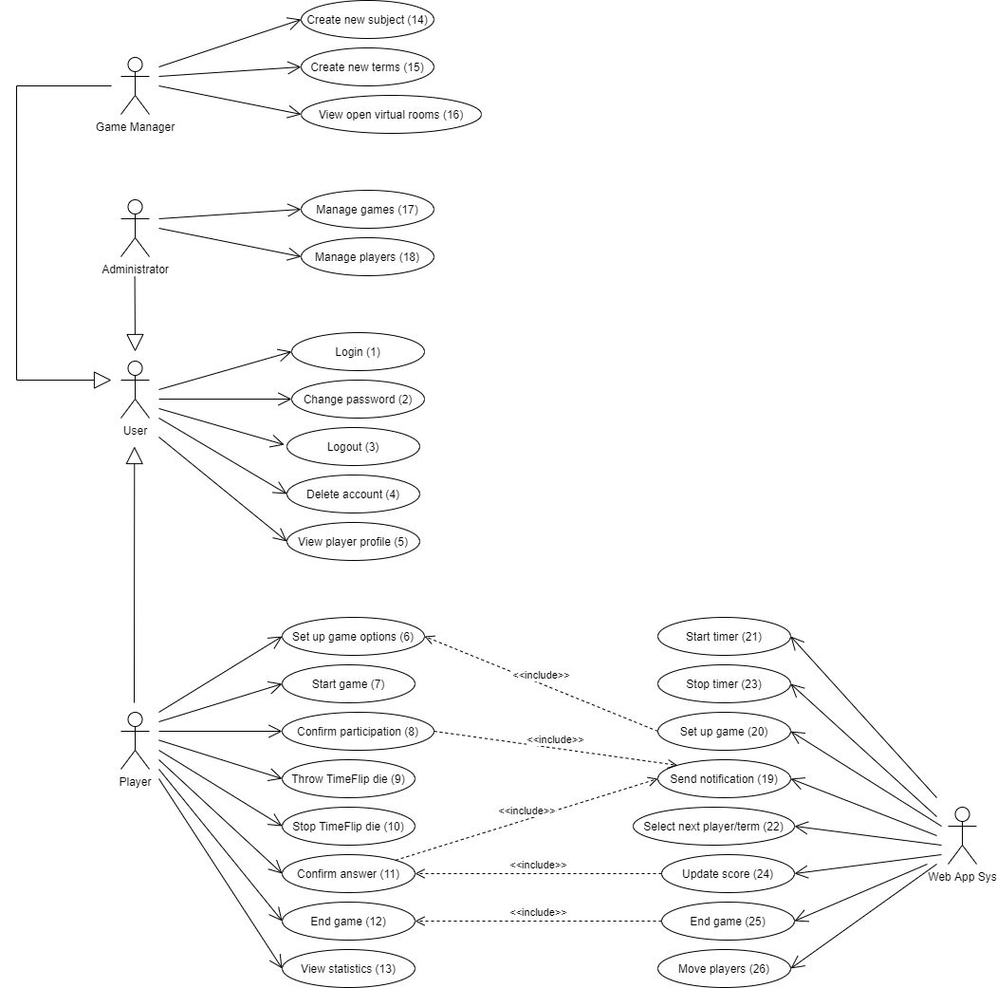

## 2.3. Use-Cases

**2.3.1 Actor: User**

### Log-in (1)

Precondition:

* The system is running.
* User is on the start page.
* User to be logged in exists.

Procedure:

1. User enters his/her username and password
2. Clicks on "Login".

Success: User can now view the virtual game lobby.

No success: User receives an error message, registration is needed.

### Change password (2)

Precondition:

* User is logged in.
* User knows its “old” password.

Procedure:

1. User clicks on the menu item “Settings”.
2. After the settings are displayed, user selects option “Change password”.
3. Inserts both the old password and the new one, which is confirmed by a second entry.
4. User saves the changes.

Success: Password has changed.

No success: User receives an error message if:

* New password and its confirmation do not correspond.
* Old password is not valid.

### Log-out (3)

Precondition:

* User is logged in.

Procedure: User clicks “Log out”.

Success: User exits the virtual game lobby.

### Delete account (4)

Precondition:

* User is logged in.

Procedure:

1. User clicks on the menu item “Settings”.
2. After the settings are displayed, user selects option “Delete account”.
3. User confirms the deletion.

Success: Account and data related to it are deleted.

No success: User receiver an error message.

### View player profile (5)

Precondition:

* Player is logged in.

Procedure:

1. Player clicks on its name or the name of another player.
2. The player’s profile can be viewed, along with its information:
   * Games won by subject area
   * Total number of games played
   * Number of games won
   * Number of games lost
   * Players played with

**2.3.2 Actor: Player**

### Set up game options (6)

Precondition:

* At least 2 teams with at least 2 players
* Each team has a device with a browser available
* At least 1 player per team is in the virtual game lobby.
* At least 3 subject areas with 30 terms each are available.

Procedure:

Users enter

* The appropriate team division.
* The selected topic of the terms to be guessed.
* The maximum points for a victory.

Success: Everything is ready, waiting for the game to be started.

### Start game (7)

Precondition:

* Game has been set up.
* At least two teams with at least 2 players
* Each team has a device with a browser available
* At least 1 player per team is in the virtual game lobby.

Procedure: A player clicks the option “Start a new game”.

Success: Other players are informed that somebody started the game and a notification is sent to them in order to confirm their participation.

### Confirm participation (8)

Precondition:

* Player started the game.
* All players are registered for the game.

Procedure: Players click “OK” on the confirmation.

Success: Players go to virtual game room, where they can view the teams involved and the number of rounds played.

### Throw TimeFlip die (9)

Precondition:

* A new round has started.
* System has chosen a player and a term.

Procedure: Player that has been chosen to explain the term flips the die.

After throwing the TimeFlip, the face at the top of the die is the one determining how and in what time the explanation has to be done.

* There is a letter on each side:
  + P = Pantomime
  + R = Rhyme
  + S = Speaking
  + Z = Drawing
* A number near the letter:
  + 1 = 1 point
  + 2 = points
  + 3 = 3 points
* And another number indicating the time:
  + 1 minute
  + 2 minutes
  + 3 minutes

Success: Timer begins and players start guessing.

### Stop TimeFlip die (10)

Precondition:

* TimeFlip has been thrown.
* Term has been guessed or time is over.

Procedure: Once the current term has been guessed by the other team members, the die is flipped to any other side, in order to stop the timer.

Success: A notification is sent to the other team, where they confirm either that the playing team guessed the term or it didn’t.

Alternative: Die is not flipped because the time is over before the team players could have guessed the correct term.

### Confirm answer (11)

Precondition:

* Round has terminated.

Procedure:

Opposing team clicks “Confirm” to confirm the answer of the other team

* Opposing team confirms that the playing team guessed the term.
* Opposing team confirms that the playing team didn’t guess the term.

Success: New score for the guessing team is automatically determined.

Alternative: Opposing team clicks “Note violation” in case a rule was violated during the round

* Opposing team confirms that the playing team violated a rule.

### End game (12)

Precondition:

* Player is participating in the game

Procedure: Player clicks “End game”.

Success: Game ends for the player and he returns to the virtual game lobby.

### View statistics (13)

Precondition:

* Player is inside the virtual game lobby.

Procedure:

Player clicks “View past games” and the information is shown on a new window

* Highscores
* Number of games per subject area
* Number of correctly guesses terms per subject
* Number of incorrectly guessed terms per subject

Success: Statistics on past games are shown.

**2.3.3 Actor: Game Manager**

### Create new subject (14)

Precondition:

* Player is logged in.
* Player has the role “Game Manager”.
* Subject is not in the list of topic areas.

Procedure:

1. Game Manager goes to the section where all the topics, along with its terms, are shown.
2. Selects the subject area.
3. Clicks on “New subject area”.
4. Game Manager fills the new window with the name of the topic.
5. Clicks “OK”.

Success: The subject is added to the list of topic areas.

No success: If subject already exists, an error message is shown.

### Create new terms (15)

Precondition:

* Player is logged in.
* Player has the role “Game Manager”.
* Term is not in the list of terms.

Procedure:

1. Game Manager goes to the section where all the topics, along with its terms, are shown.
2. Selects the subject area.
3. Clicks on “New term”.
4. Game Manager fills the new window with the term along with its definition.
5. Clicks “OK”.

Success: The term is added to the list of terms of a specific topic.

No success: If term already exists, an error message is shown.

### View open virtual game rooms (16)

Precondition:

* Player is logged in.
* Player has the role “Game Manager”.

Procedure:

1. Game Manager clicks “View open rooms”.
2. Chooses one of the open rooms and clicks on it.
3. Receives information regarding, including the intermediate results.

Success: Game managers can view the open rooms and the intermediate results.

**2.3.4 Actor: Administrator**

### Manage games (17)

Precondition:

* Player is logged in.
* Player has the role “Administrator”.

Procedure:

* The user clicks on “Administration” – “Games” and can:

1. In case of technical issues and errors occurring with the server, administrators can choose one of the following options:
   * Start game
   * Restart the
     + If the game that it’s being played crushes, admin can restart the game restoring the amount of points and all the initial game configuration.
   * End game
2. Can calibrate the TimeFlip die and change the game mode:
   * Administrator cleans the sides of the die.
   * Rewrites and reconfigures the changes:
     + Edit the standard modality (Pantomime, Rhyme, Speaking, Drawing)
     + Edit the standard points (1 point, 2 points, 3 points)
     + Edit the standard time (1 minute, 2 minutes, 3 minutes)

Success: Administrator has access to the administration of technical views.

No success: Administrator receives an error message when calibrating the TimeFlip, if one or more sides of the die are left blank.

### Manage players (18)

Precondition:

* Player is logged in.
* Player has the role “Administrator”.

Procedure:

1. The user clicks on “Administration” – “Players”.
2. Administrator can view and sort the list of players.
3. Clicks on one of the accounts shown.
4. Performs an action on the player profile.

Success: Administrator performs actions such as adding or removing user rights.

**2.3.5 Actor: Web Application System**

### Send notifications (19)

Precondition:

* User has an account on the web application.
* User is logged in.

Procedure:

A notification is sent to the user

* To confirm their participation to a game.
* To confirm the answer at the end of a round.

Success: Users targeted can view the notification.

### Set up game (20)

Precondition:

* Players filled up the set up options for the game.

Procedure:

1. The information will be processed by the system.
2. The option “Start a new game” will be made available.
3. The players will then receive a notification to confirm their participation.
4. The actual game will start after all of them confirmed.

Success: First round starts.

No success: System waits in case not all the confirmations are confirmed.

### Start timer (21)

Precondition:

* New round has started.
* TimeFlip die has been thrown.

Procedure: System begins the countdown, which varies depending on what side of the die is at the top.

Success: Timer starts counting and players start guessing.

### Select next player/term (22)

Precondition:

* Game has started.
* Round has ended.
* Score has been updated.
* At least one player per team in virtual game room.

Procedure: System determines at random the start team and the term.

Success: The term is shown on the device of the opposing team, timer is displayed.

No success: The same term is suggested more than once in a same game.

### Stop timer (23)

Precondition:

* Round has ended.
* Player has stopped the die by flipping the top side.

Procedure:

System keeps track of the time that is passing:

* Stops the countdown immediately if a player flips the time.
* Checks if the countdown has arrived to 0.

Success: Timer has stopped and now players will receive a notification to confirm their answers.

### Update score (24)

Precondition:

* Round has ended.
* Players confirmed the answer.

Procedure:

1. New score for the guessing team is calculated, following these options:

* If the timer has expired completely, 0 points are awarded.
* If the term was not guessed, 0 points are awarded.
* If the times has not expired and the term has been guesses, the number of points written at the top side of the TimeFlip are awarded.
* If a rule was violated, 1 point is subtracted.

1. After the score has been updated:

* A new round is started and is time for the opposing team to play.

Success: Players start a new round.

Alternative:

If the maximum of points has been reached

* Winner team is shown.
* Ranking of all teams is issued.
* Players return to the virtual game lobby.

### End game (25)

Precondition:

* Maximum points has been reached.
* One or more players inform the system by clicking on “End game”.

Procedure: System selects targeted player or players and moves them.

Success: Players are moved to the virtual game blobby.

### Move players (26)

Precondition:

* Players confirmed their participation to a game.

Procedure: Players are moved from virtual lobby to a room.

Success: Players are moved from one virtual location to another.

Alternative: Game has ended, therefore players are moved from virtual game room to virtual lobby, so they can start a new game.